Contents
Section 1 - Course Structure 2
Section 2 - Angular Framework 2
1. What is Angular 2
2. What are the advantages of angular. (V. Imp) 2
3. What is the difference between the Angular JS and Angular 3
4. What is NPM 3
5. What is the CLI Tool 3
6. What is the Type script? What is the advantage of Typescript over JavaScript? 3
7. Where you will store static files in angular project 4
8. What is the role of angular.json file in angular project 4
9. What are differences between JIT and AOT in Angular? (V. Imp) 4
Section 3 - Components & Modules 5
10.What are the components in angular? 5
11. What are the selecter and Template? 5
12.What is module in Angular? What is app.module.ts file? 5
13. How an angular app gets loaded and started? What are index.html, app-root, selector and main.ts? (V. Imp) 5
14. What is a Bootstrapped Module & Bootstrapped Component? 5
Section 4 – Data Binding 5
Section 5 - Directives 5
20. What are Directives? and What are the types? 5
21. What is *NgIf Structural Directive? 6
22. What is *NgFor Structural Directive? 6
23. 6

Section 1 - Course Structure

Basic | Advanced
- Angular Framework | - Routing
- Components & Models | - Observables/HTTP Client/RxJS
- Data Binding | - TypeScript-Basics
- Directives | - Typescript-OOPS
- Decorates & Pipes | - Angular Forms
- Services & Dependency Injection | - Authentication
- Component Lifecycle-Hooks | - Parent & Child Components Communications

Section 2 - Angular Framework

What is Angular
Angular is a Component based framework for building structed, scalable and single page web applications for client side.

What are the advantages of angular. (V. Imp)
- It is Relatively simple to build the single page application using component-based architecture.
- Easy to make flexible and structed applications using oops friendly.
- It is a cross platform and open source (Free).
- Reusable Code using services-it means you can write the code in one place and use it in many places.
- Testability using specs.ts file- in real case it is difficult to do the unit testing but in angular case it is providing the specs.ts file.

What is the difference between the Angular JS and Angular
Angular JS | Angular
Its only supports java script | Its supports both java script and Type script.
This framework has MVC architecture | It is component-based architecture
It is not having the CLI tool | It is having CLI tool
It does not use dependency injection | It I will use dependency injection
It will not support mobile browser | It will support mobile browser
It is not so fast | It is very fast

What is NPM
- NPM Stands for (Node Package Manager), it is an online repository form where you can get thousands of free libraries which can be used in your angular projects.
- To working with Angular, we need to install node JS, because google is developed both node and angular.
- So, they are keeping library’s for commonly in NPM for Both.
- That’s why we must download Node JS before working on Angular.

What is the CLI Tool
- CLI Stands for (Command Line Interface) tool that you use to initialize and develop angular applications.
- For using CLI we can create components and angular projects.

What is the Type script? What is the advantage of Typescript over JavaScript?
TypeScript is a programming language developed by Microsoft that extends JavaScript by adding static typing and advanced features, making it easier to build large, scalable applications.
- Type Script is a Strongly typed language – (in let name: string = “Siva”; - here in the name keyword you can’t assign the integer value if assign it will show compile time error).
- Type Script is a super set of the JavaScript.
- Type script has object-oriented features, but java scrip doesn’t.
- Type script will detect compile time errors; java script will detect run time errors.
- Types scripts are containing (type system, Enums, generics, interfaces), but java script does not contain these.
- But browser can’t read the Type script, so that the TS compiler will compile the TS code to JavaScript.

Where you will store static files in angular project
- We can use assets folder to store static files like (images).

What is the role of angular.json file in angular project
The Angular.json file is the primary configurations file of the angular project. And also, we can call it index of the project.

What are differences between JIT and AOT in Angular? (V. Imp)
Both AOT and JIT will use to compile the Angular Type script components to JavaScript, because Browser cannot support the TypeScript code.
JIT | AOT
stands for Just in time compile | stands for Ahead-of-time
It will compile your application in the browser in the run time. It is a default until angular 8 | It will compile your application and libraries at build time; this is default form angular 9

No table of figures entries found.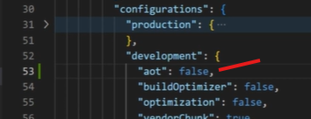
For example, and real time practice.
You can make “aot”: false, in angular.json file like this. If you make AOT false, then JIT will compile the application.

Section 3 - Components & Modules

1.What are the components in angular?
Components are the most basic UI building blocks of an angular application. One component will contain (1 html, 1 CSS, 1 .ts, 1 sepc.ts) files.

2. What are the selecter and Template?
The Selecter is used to identify each component Uniquely. Into the components tree. A template is a HTML view of the angular component.

3.What is module in Angular? What is app.module.ts file?
Module is a place where you can group the component, directives, pipes and services, which are related to the application.
For Small case applications one app.module.ts is enough.

4. How an angular app gets loaded and started? What are index.html, app-root, selector and main.ts? (V. Imp)
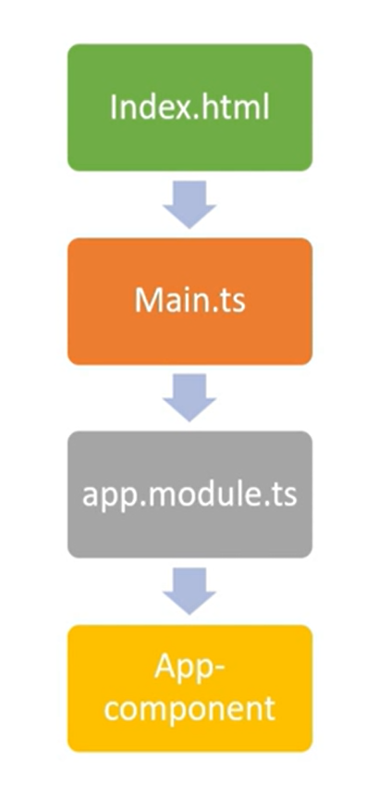
Angular is used to create a single page application. Index.html is that single page.
Index.html file invoke the main.js file it is JavaScript version of the main.ts file.
Main.ts file is like the entry point of the web application. It complies the web app and bootstraps the AppModule to run in the browser.

App Module file will then bootstrap the Appcomponent.

App-component or app-root component is the html which you will see finally.

5. What is a Bootstrapped Module & Bootstrapped Component?
When the angular web application will start then the first module launched is the bootstrapped module and same is true for the bootstrapped component also.
A bootstrapped component is an entry component that angular loads
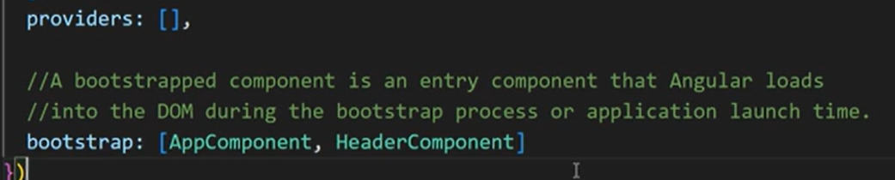
Here the above image both app and header components are the bootstrapped components.

Section 4 – Data Binding

1. What is Data Binding in Angular? (V. Imp)
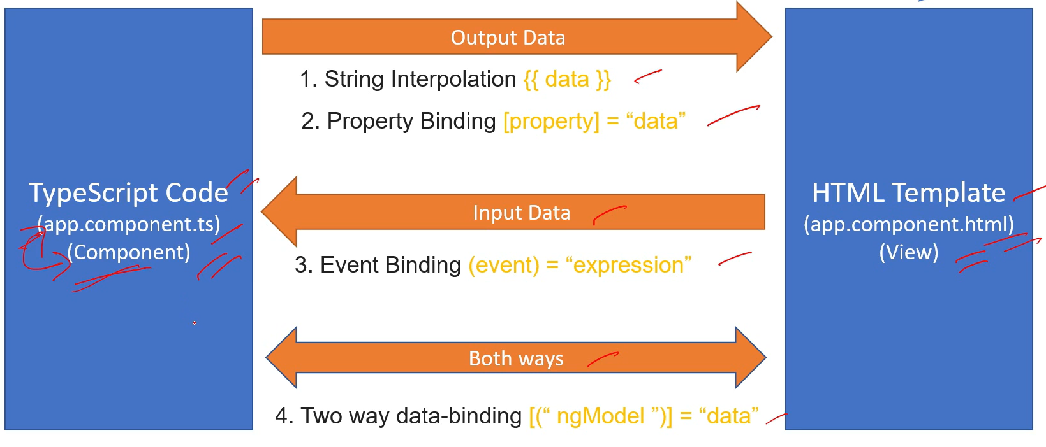
Data Binding is the way of communicate between your typescript code component to Html View.
They are 3 Types of data binding technics:
- String Interpolation
- Property Binding
- Event Binding
- Two-way Binding.

2. What is String Interpolation in Angular?
String Interpolation is a one-way data binding technique that is used to transfer the data to Type script code component to Html view.
String Interpolation will work only String type only not numbers or other types.
It is Represent the inside {{data}} double curly braces.

3. What is Property Binding in Angular?
Property Binding is a superset of interpolation. It can do whatever interpolation do. In additionally it can support any type of data or non-string like Boolean values also.
In this case what is the use of String interpolation? The answer is Compare to Property binding syntax interpolation syntax is very simple.
If you are data is string type better to use interpolation, if any other type use property binding.
4. What is Event Binding in Angular?
Event binding is used to handle the events raised by the user actions like button click.

5.What is Two-way Binding in Angular? (V. Imp)
Two-way data binding is used to exchange the data from component to view and same way view to component in same time.
It is a combination of both property and event binding.

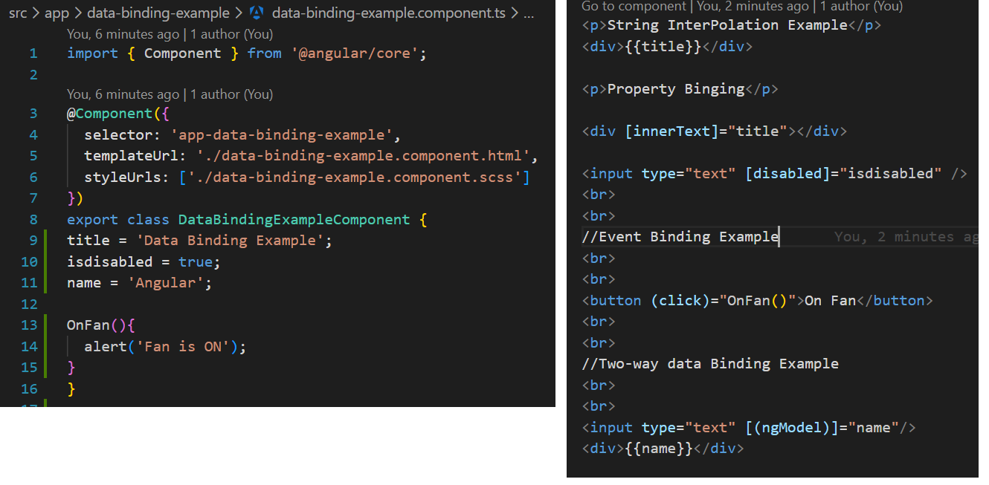

Section 5 - Directives

1. What are Directives? and What are the types?
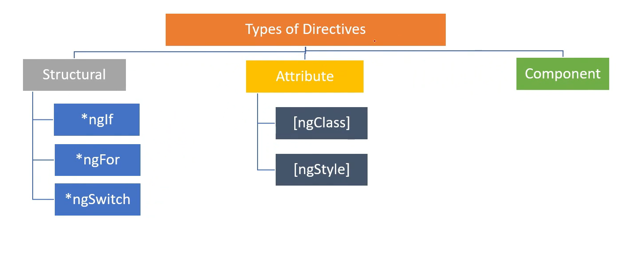
Directives are classes that will add additional behaviours to elements in your angular application.
They are 3 types of Directives
Structural Directives: Structural Directives can change the appearance of DOM by adding or removing elements.
Attribute Directives: Attribute Directives Can change the appearance or behaviour of a elements.
Component Directives: Component Directives are the Directives with its own template.

2. What is *NgIf Structural Directive?
NgIf Directive is used to add or remove items based on if condition
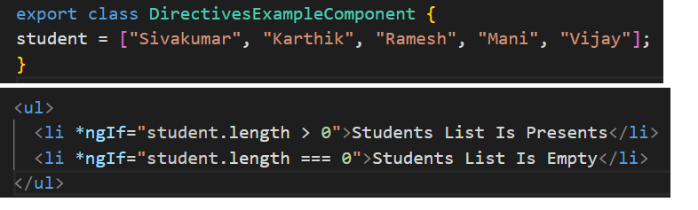

3. What is *NgFor Structural Directive?
NgFor Directive is used to iterate a list of items and then display them.
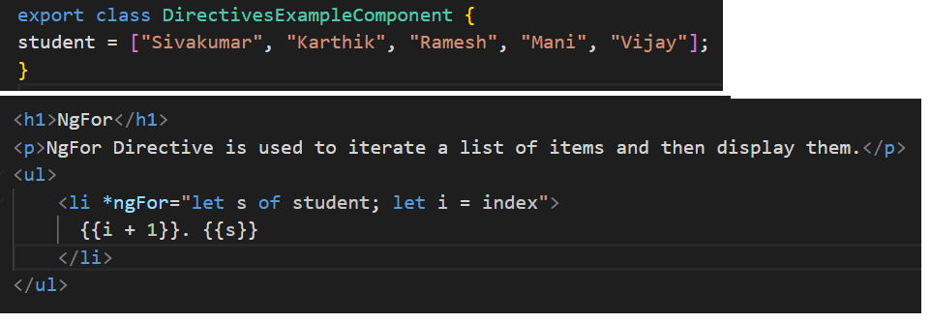

4. What is the *NgSwitch Structural Directive?
NgSwitch is the combination of the NgSwitchCase and NgSwitchDefult that are both structural Directives.

